MobileDevelopment ClassLab 09/04/2019 Paul Fogarty SB18012

Image Capture phonegap app.

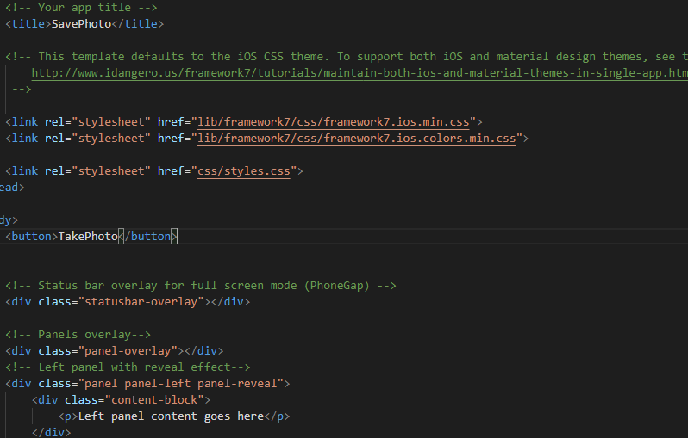

Inserting the button “TakePhoto”

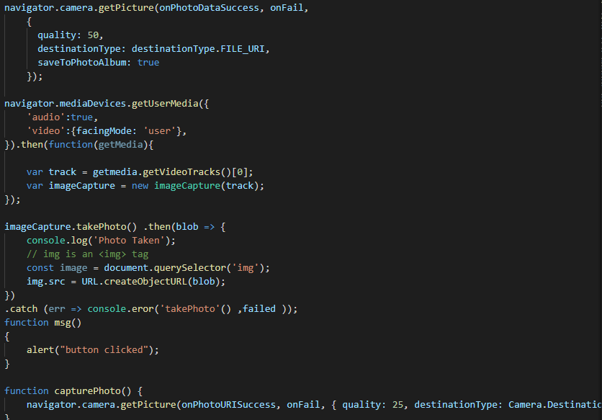Code to save Image

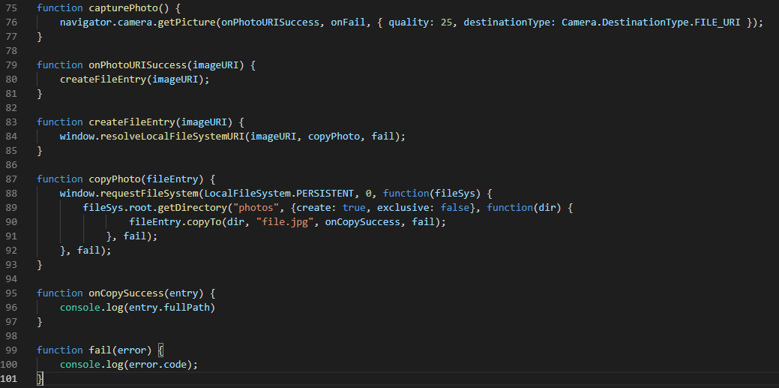

Code to retrieve image